**1. Introduction**

Decision Trees can be used for both classification and regression. The methodologies are a bit different, though principles are the same. The decision trees use the CART algorithm (Classification and Regression Trees). In both cases, decisions are based on conditions on any of the features [Abhijit Roy].Decision trees use multiple algorithms to decide to split a node into two or more sub-nodes. The creation of sub-nodes increases the homogeneity of resultant sub-nodes [Nagesh Singh Chauhan]. In a decision tree, for predicting the class of the given dataset, the algorithm starts from the root node of the tree. This algorithm compares the values of root attribute with the record (real dataset) attribute and, based on the comparison, follows the branch and jumps to the next node. For the next node, the algorithm again compares the attribute value with the other sub-nodes and move further. It continues the process until it reaches the leaf node of the tree [Sonoo Jaiswal].

**2. Dividing the data into a training and test set:**

Begining of this section, taking 70 percent of the data to determine the size of the sample and the value of sample size is 4922. The train dataset is designed to contain 70% of the original data and also the test dataset is designed to contain 30% of the original data. After data partitioning, train data contain 4922 observation and test data contain 2110 observation information.

**3. Training the model on training data and tune the complexity parameter:**

At first, Using the train dataset we are creating training based model and then find the cp value for corresponing to the lowest value of xeror value of the training based model. After that, using the cp value we are creating the final model and derived the decision tree.

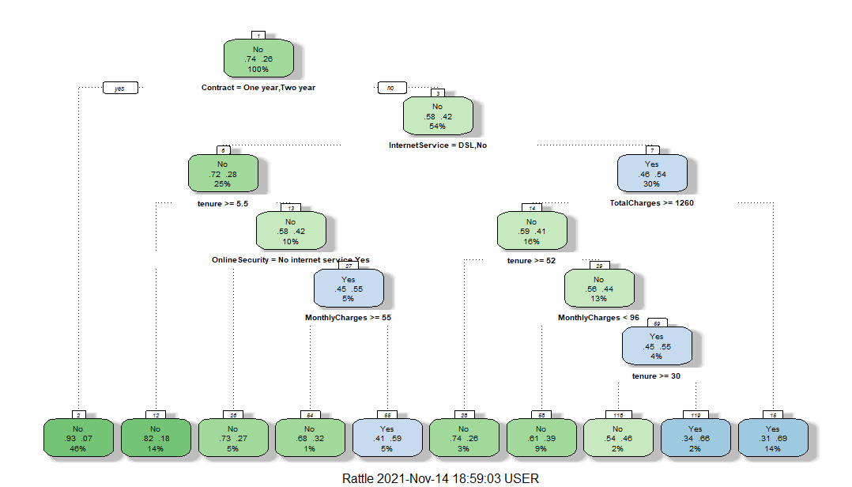

**Figure 1: Decision tree for the dataset.**

**4. Interpreting the decision tree**

To understand what the decision tree is saying, we want to start with the root of the tree (the first decision node). Looking at the first decision node, we know that the variable that the decision is determined by is whether or not the customer has churned. If the contract is not one year or two year and if InternetService is not DSL or No then the probability of occurring churn will be 0.46 and node number is 7.

If the contract is not one year or two year and if InternetService is not DSL or No and if total charges is not greater or equal 1260 then the probability of occurring churn will be 0.31 and node number is 16.

If the contract is not one year or two year and if InternetService is DSL or No and if tenure is not greater than or equal 5.5 and if Online Security is not have any internet service then the probability of occurring churn will be 0.45 and node number is 27.

If the contract is not one year or two year and if InternetService is DSL or No and if tenure is not greater than or equal 5.5 and if Online Security is not have any internet service and if Monthly Charge is not greater than 55 then the probability of occurring churn will be 0.41 and node number is 55.

If the contract is not one year or two year and if InternetService is not DSL or No and if total charges is greater than or equal 1260 and if tenure is not greater than or equal 52 and if monthly charges is not less than 96 then the probability of occurring churn will be 0.45 and node number is 59.

If the contract is not one year or two year and if InternetService is not DSL or No and if total charges is greater than or equal 1260 and if tenure is not greater than or equal 52 and if monthly charges is not less than 96 and if tenure is not greater or equal then the probability of occurring churn will be 0.34 and node number is 119.

**5. Conclusion:** From the output, we can clearly see that the probability of occurring churn will be 0.46, 0.31, 0.45, 0.41, 0.45 and 0.34 for the corresponding node 7, 16, 27, 55, 59, and 119 respectively.

**Reference:**

Abhijit Roy. (n.d). *A Dive Into Decision Trees*. Retrieved November 7, 2020, from

https://towardsdatascience.com/a-dive-into-decision-trees-a128923c9298

Nagesh Singh Chauhan. (n.d). *How do Decision Trees work?.* Retrieved January 2020, from

https://www.kdnuggets.com/2020/01/decision-tree-algorithm-explained.html

Sonoo Jaiswal. (n.d). *Decision Tree Classification Algorithm*. Retrieved from

https://www.javatpoint.com/machine-learning-decision-tree-classification-algorithm